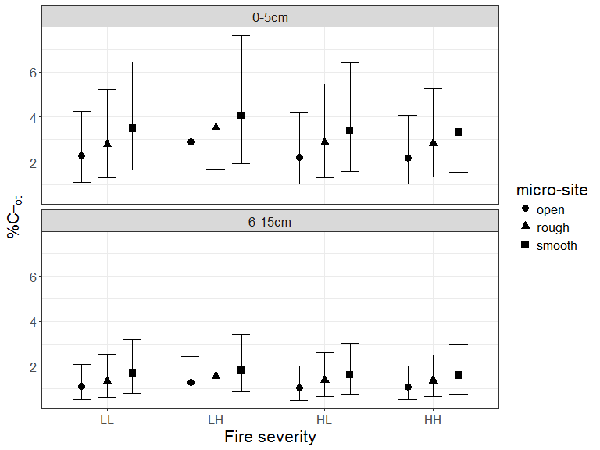

Figure 3. Predicted mean total % C (with upper and lower 95% confidence bounds) from ensemble modeling categorized by fire severity and site characteristics. Fire severity was rated low (L), tree crowns unaffected, or high (H), tree crowns affected. Sites selected from two successive fires separated by 8 years, soil collected 10 years post fire, yielding four severity combinations (LL, LH, HL, HH). Soil depth was characterized by two layers (0-5cm; 6-15cm). Micro sites sampled were: adjacent to base of rough barked trees (Rough); adjacent to base of smooth barked trees (Smooth); open patches largely between tree crowns (Open).